MECH431 Term Report on Economic Analysis of a STEM Toy Subscription Box Startup

Ratthamnoon Prakitpong

#63205165

**Table of Contents**

[Introduction 3](#__RefHeading___Toc208_1186224105)

[Execution 4](#__RefHeading___Toc210_1186224105)

[Data 5](#__RefHeading___Toc212_1186224105)

[Expected Costs 5](#__RefHeading___Toc214_1186224105)

[Design 5](#__RefHeading___Toc216_1186224105)

[Prototyping 5](#__RefHeading___Toc218_1186224105)

[Manufacturing 7](#__RefHeading___Toc220_1186224105)

[Shipping 8](#__RefHeading___Toc366_1186224105)

[Other costs 8](#__RefHeading___Toc224_1186224105)

[Expected Revenues 8](#__RefHeading___Toc226_1186224105)

[Economic Analysis 11](#__RefHeading___Toc228_1186224105)

[Before Tax Cash Flow 11](#__RefHeading___Toc230_1186224105)

[Taxes 12](#__RefHeading___Toc232_1186224105)

[Opportunity Cost and Rate of Return 12](#__RefHeading___Toc234_1186224105)

[Risk Analysis 13](#__RefHeading___Toc236_1186224105)

[Note on Non-Economic Concerns 15](#__RefHeading___Toc238_1186224105)

[Ethics 15](#__RefHeading___Toc240_1186224105)

[Sustainability 15](#__RefHeading___Toc242_1186224105)

[Conclusion 16](#__RefHeading___Toc244_1186224105)

[Bibliography 17](#__RefHeading___Toc246_1186224105)

[Appendix 21](#__RefHeading___Toc248_1186224105)

[Risk Calculations 21](#__RefHeading___Toc371_1186224105)

# Introduction

As a mechanical engineering student early in their career, there are not a lot of businesses that I can realistically start; given low initial capital[1] and my personal skill as in mechanical design, however, an engineering toy subscription box is a rare gem. Still, in the past, it would be much less viable to create subscription of low volume, high variation toys due to manufacturing cost and hassle, compared to simply curating and reselling items like cosmetics[2]; however, due to recent advances in rapid prototyping[3], both in price and ease of use, it has become possible for an engineering student to start this business. Parents of K12-and-under students can purchase this subscription to give their kids fun toys to play with, while also teaching them about engineering and inspiring them to pursue a STEM career path.

In this paper, we will look investigate the economics of starting an engineering toy, including cash flows, taxes, rate of returnm, risks, and impacts of social and environmental on the economics. Similar businesses in other countries, like KiwiCo[4] or Green Kids Craft[5] in USA, can serve as a good indicator of parameters for evaluating this business plan, including price or cost.

# Execution

Due to uncertainty of the current pandemic market, as well as saturation of competitive products, this small business is best executed as a startup (sole proprietorship for tax purposes) due to low initial costs and ease of pivoting. Initial funding, labour, as well as office space will come free of interests/charge from my personal resources; in return, I get 100% ownership of the company and its assets. This may change in the future when the business becomes established and stable, workers are hired, or stake in the company is sold to investors.

Given that the product is essentially a small design project, the execution steps can be based on the design process commonly taught in a mechanical engineering design class:

1. Design
2. Prototyping
3. Manufacturing
4. Shipping

These steps are then repeated for each crate we ship, repeated on a monthly cycle since new boxes will be shipped to subscribers on a monthly basis. This totals to a set of 12 boxes per year. Shipping costs will be included in product cost in order to stay competitive with other online retail brands.

For the early stage of this company, we will focus on selling the product within Canada. While many similar companies are based in the US, there are not many are based in Canada, which reduces our competition. Additionally, COVID-19 further complicates the already complicated world of international shipping, so for this analysis, we will only focus on selling domestically. Consistently so, all prices brought up in this report will be in CAD unless stated otherwise.

Many startups go through multiple pivots until it becomes profitable, so, given limited knowledge of future products, doing more analysis than necessary on this set of products is likely a wasted effort. Therefore, the time span chosen for this analysis will be as small as possible, while giving us a reasonable picture of whether the business will survive or not. We can assume that that time would be when chance of success goes from positive to negative, which would be at about 50%. According to a source[6], “45% (of new businesses fail) during the first five years”, so five years can act as the most reasonable time span for this analysis.

# Data

## Expected Costs

Associated with each steps of execution are costs that will be discussed. For cost estimations, there are established companies selling similar products that we can reference from, and there are companies online that sells related products and services that we can take quotes from as well. Viewing this business from a cash-strapped startup’s perspective, I will be sharing any personal resources I can share to get the business up and running, including time, space, or hardware, free of charge.

In summary, the table below lists all costs, initial and marginal, for this business. The individual sections break down costs per each stage in more detail, with items costing none omitted for brevity:

|  |  |  |  |
| --- | --- | --- | --- |
| Item | Cost | Type of cost | Stage |
| 3D printer | $303.99 | Fixed | Prototyping |
| Tabletop CNC and laser cutter | $437.71 | Fixed | Prototyping |
| Consumables (plastic, wood) | $6.50 | Monthly | Prototyping |
| Toy box set | $11.40 | Per shipped box | Manufacturing |
| Box shipping | $20.35 | Per shipped box | Shipping |
| Shop website | $40 | Monthly | Other |
| Payment fee | 3.5% + $0.30 | Per shipped box | Other |

Table 1 – Expected Costs

### Design

As previously reasoned, design will be done in-house by myself to reduce cash spent. While regular design firms may require established design software such as SolidWorks or AutoCAD, I will be using software that are free for commercial use, such as FreeCAD or Blender, to save on software cost. Computer hardware needed for design can come from my personal laptop. Hence, the design step has no incurred cost to the business.

### Prototyping

In terms of prototyping, this can be done in-house as well. Associated costs can be broken down into tools and consumables. Seeing that most shipped pieces are either small plastic pieces or cutted wood sheet, the two main prototyping tools that come to mind are 3D printer and laser cutter. They can be bought online. While they can be a large initial investment, in-house tools provide high flexibility in prototyping stage, which can reduce labour cost since I can spend less time making the prototypes, as well as provide salvage value if this startup proves unsuccessful. I can provide the required hand tools from my own collection.

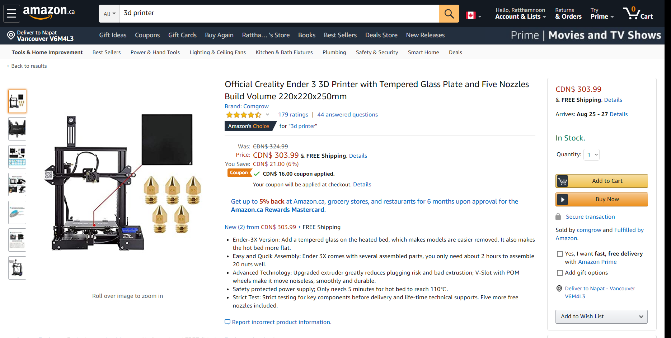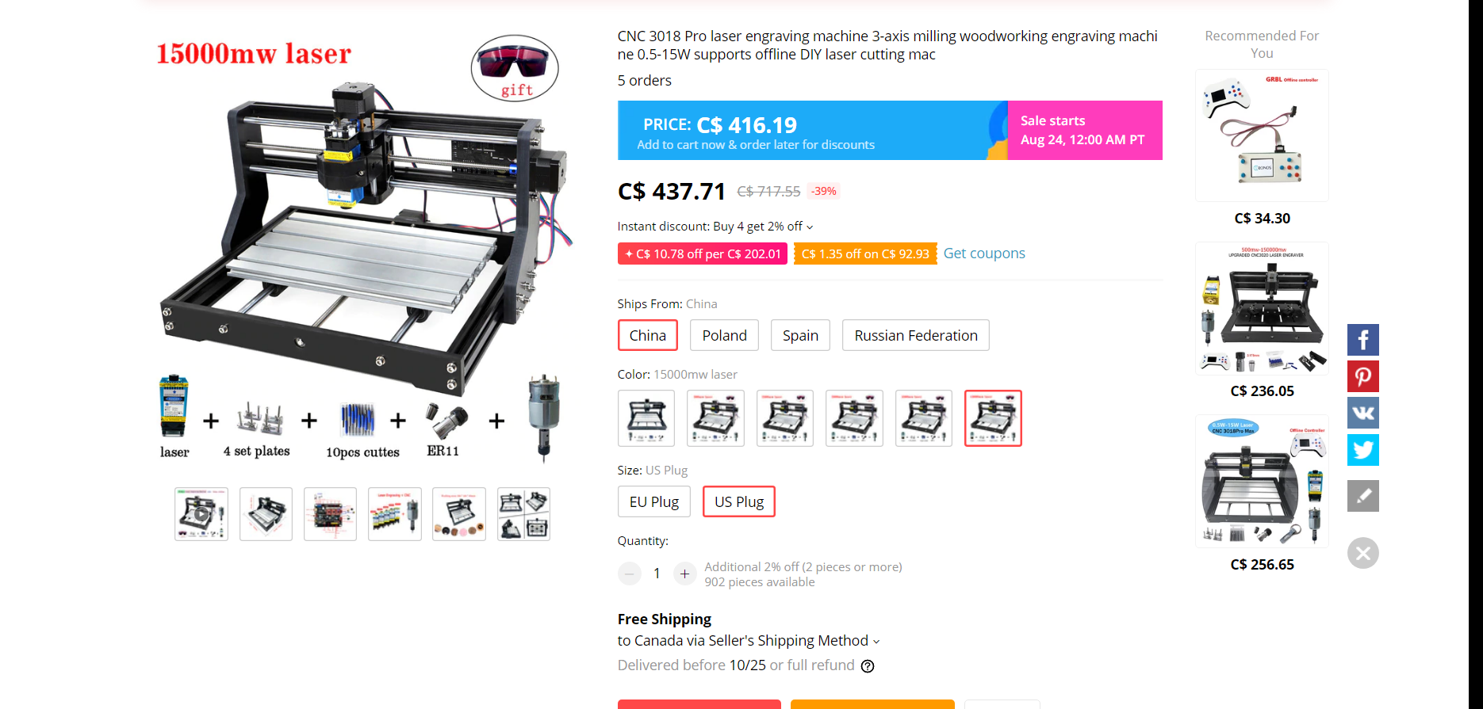Figure 1 – Rapid Prototyping Tools[7][8]

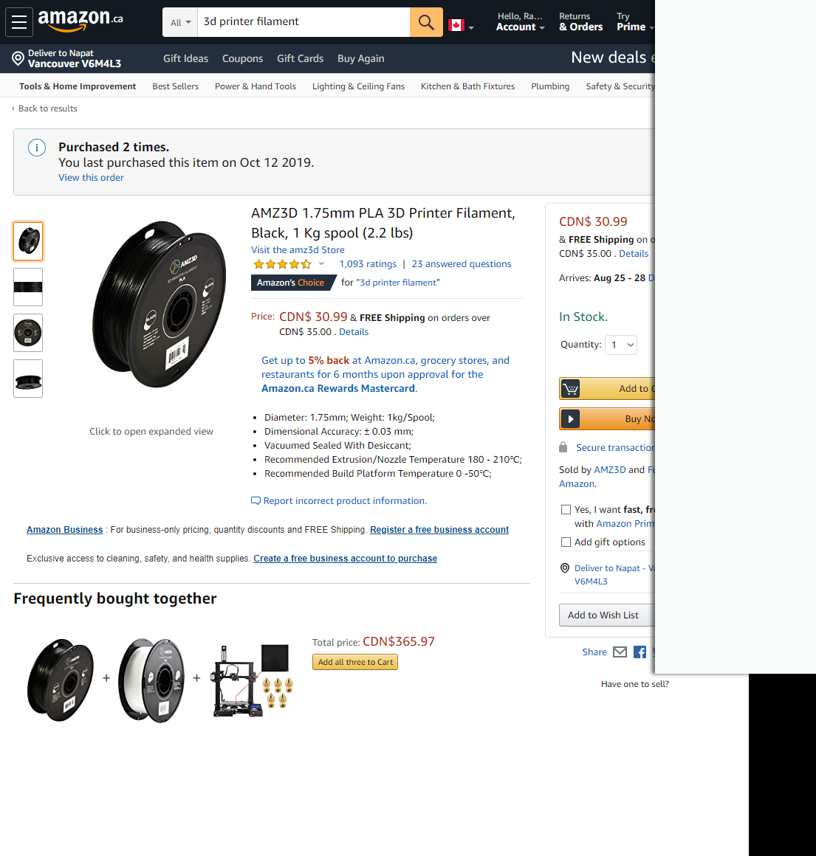Consumables can be bought at retail stores or online. From personal experience in design classes and personal projects, it takes about a quarter of filament spool or a sheet of laser-cut-ready wood to prototype and finalize a design. These two average out to be $6.50 of consumables per project ([30.99/4+5.2]/2=6.47).

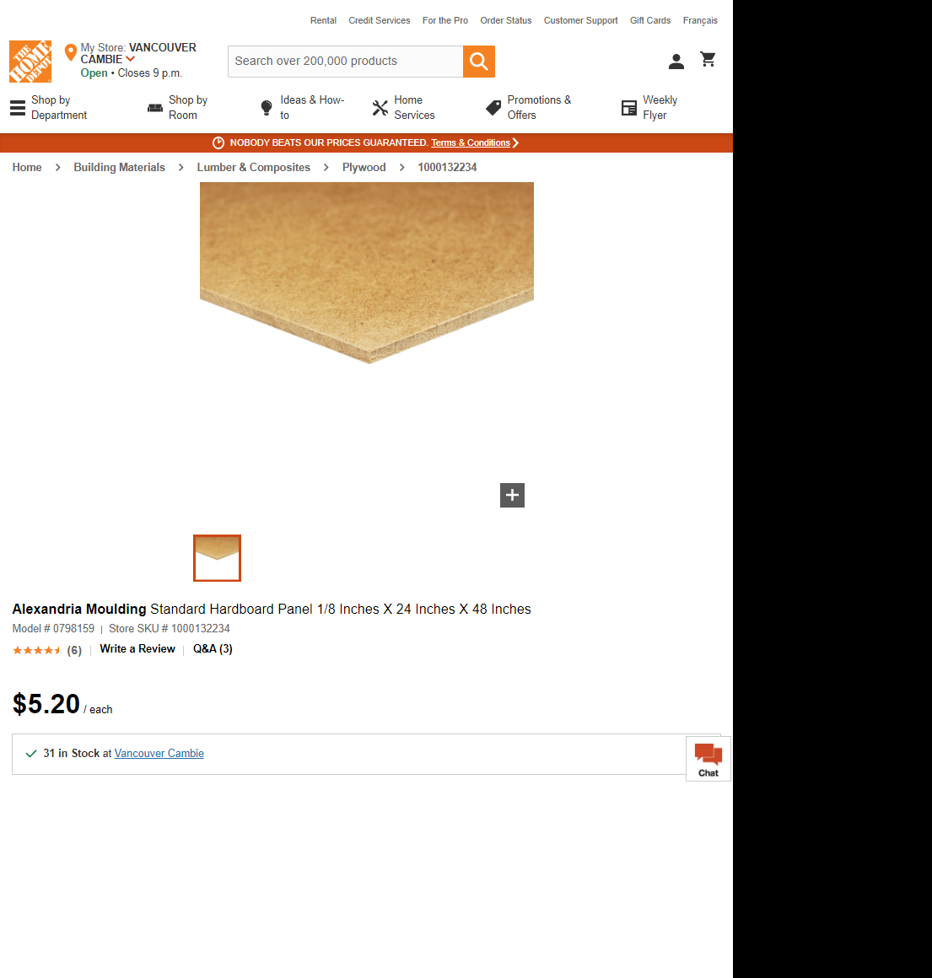

Figure 2 – Consumables in Rapid Prototyping[9][10]

### Manufacturing

After the design of the toy is finalized, the product itself has to be manufactured. Looking at similar products like Kiwico and Green Kid Crafts, we can see that there are multiple components to to each box set:

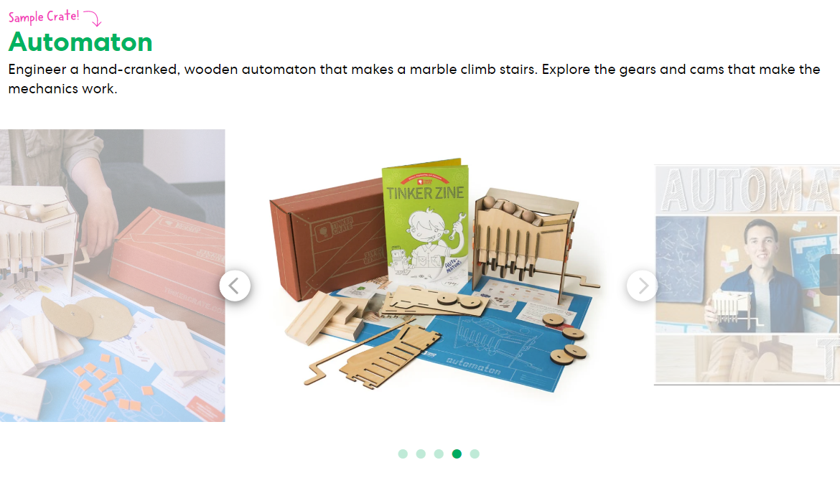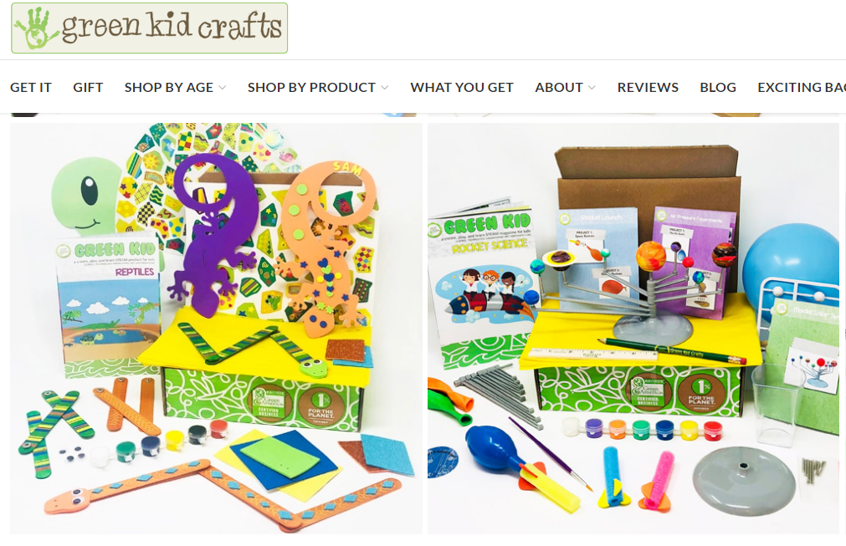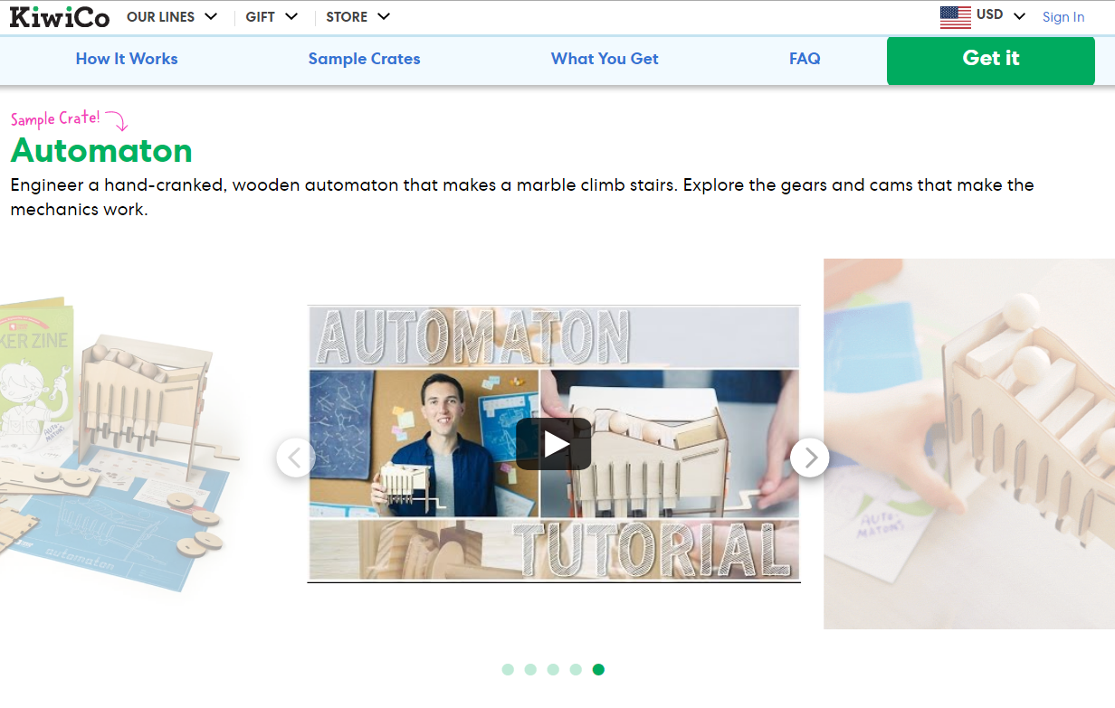

Figure 3 – Sample Products from Similar Companies’ Website[11][12]

Some common components we should also include in our product are:

1. Toy pieces
2. Instructional booklet
3. Instructional video
4. Packaging

Associated with each components, we can break down the marginal costs:

1. Toy pieces: To save cash, we can reuse the prototyping tools to manufacture these items, which means that we only need to buy consumables. Since we have an estimate of consumable costs during prototyping, and we iterate through multiple sets of pieces during prototyping whereas in production we only make one set of pieces, we can use prototyping consumable costs as our reasonable upper bound for what each box’s toy pieces should cost to produce. This is $6.50.
2. Instructional booklet: I can design the books in-house using free software (ie Scribus and Inkscape). From an online vendor[13], printing in Vancouver costs $125 per 50 booklets, which averages out to $2.50 per book.
3. Instructional video: I can produce the video in-house for free using my phone’s camera and free video editing software (ie Windows Movie Maker). There are online platforms (ie Youtube) that will host videos for free.
4. Packing: I can design the box in-house. From an online vendor[14], 250 colour-printed 11inx8.5inx2in boxes costs $600, averaging out to $2.40 per box.

In total, each additional box shipped costs $11.40 per box.

### Shipping

As a reasonable upper bound, we can say that the farthest distance we’ll ship within Canada is from Vancouver to Toronto. Put into Canada Post’s calculator[15], we can see that our parcel will cost $20.35 to ship.

### Other costs

While a good part of running a startup is the lack of administrative cost, selling goods online still requires some administration in the form of a shop website. Looking at an online shopping platform’s pricing[16], using their basic shopping platform will cost $29 USD per month, which translates to $40 per month. There is also an upper-bounded payment fee of 3.5% + 30¢ per purchase.

Another item increasing our total costs is inflation. For estimation, we can look at historic average, where Canada’s average annual inflation from 2000 to 2020 is 1.81%[17].

Lastly, we need to account for taxes in our purchases. Current tax rate in BC totals to 12% (GST+PST)[18].

## Expected Revenues

A reasonable method to estimating our revenue is to look at similar companies operating in other countries, then scaling the revenue down or up to Canada. Many of these companies are private, so their earnings are not public information; however, we can use news articles and estimation websites to get an approximate idea. Given that Kiwico (est. 2011) is the highest profile company in this field, we can reference our revenues on them.

A company profiling website estimates Kiwico’s annual revenue to be $100 - $500 million USD[19]. Another website puts it at $10 million USD[20]. While these estimates vary wildly, a Forbes article provides a better insight, stating that Kiwico’s total revenue is $100 million USD in 2018[21], seven years after opening. To break that down into yearly revenue, we need more data.

According to a source[22], “in 2011, the subscription e-commerce market was $57 million (USD), and by 2016 it had ballooned to $2.6 billion (USD)”. Given that Kiwico got started around this time period, we can say that its growth is at least at market average. Given that the company was backed by multiple venture capitalists[23], and those investors tend to back early startups with potential for exponential growth, we can assume that this company, and the field as a whole, is grows at an exponential rate. Doing the math, we can find that growth rate is 72.6% per year:

2600 = 57 \* (1 + i)7

i = 72.6%

Knowing this, we can estimate Kiwico’s yearly revenues as follows, where each xn represents Kiwico’s estimated earnings at n-th year in millions USD:

100 = x1 + x2 + ... + x7

100 = x \* 1.7260 + x \* 1.7261 + ... + x \* 1.7266

x = x1 = 1.63

x2 = 2.81

x3 = 4.85

x4 = 8.36

x5 = 14.44

x6 = 24.92

x7 = 43.00

The last earning value is in the middle of the two websites’ estimate (between $10 and $100 million), so we can reasonably say that our calculation matches online estimates well.

Given that the most popular subscription option on Kiwico costs $28.95 USD a month[24], we can estimate amount of boxes shipped per year by dividing the numbers. This ignores inflation and price increases, which results in a lower-bound estimate of shipped boxes. yn represents Kiwico’s estimated number of shipped boxes at n-th year:

yn = xn \* 1000000 / 28.95

y1 = 56202

y2 = 96999

y3 = 167409

y4 = 288931

y5 = 498665

y6 = 860643

y7 = 1485379

To convert these numbers into ones we can use, there are two main considerations. Firstly, Canada’s population is smaller than USA, where Kiwico is based, resulting in a smaller market and lesser sales. For simple estimation, we will scale down Kiwico’s sales using population, with Canada’s population being 37742154 and USA’s being 331002651[25], and assume that Kiwico makes negligible sale outside of USA. Secondly, Kiwico’s products are geared towards all ages, presenting eight lines of monthly boxes[26], whereas this startup focuses only STEM toys, resulting in one line of box per month. Again for simplicity, we can scale number of sales down by number of product lines. These scales result in the following estimated number of annual shipped boxes for our company:

zn = yn \* (37742154 / 331002651) \* (1 / 8)

z1 = 801

z2 = 1383

z3 = 2386

z4 = 4118

z5 = 7107

z6 = 12267

z7 = 21171

As a similar product, we can also set price in line with Kiwico’s, being $38.17 per box[24]. Therefore, yearly expected revenues are as follows:

wn = zn \* 38.17

w1 = 30574.17

w2 = 52689.11

w3 = 91073.62

w4 = 157184.06

w5 = 271274.19

w6 = 468231.39

w7 = 808097.07

Given the competitive nature of subscription box business, we can assume that we will not be raising prices to inflation within our analysis time span.

# Economic Analysis

## Before Tax Cash Flow

While annual revenue has already been calculated in the data section, we still need to do some calculation to annualized the costs. We have identified three types of costs: (1) fixed, (2) monthly, and (3) per shipped box.

For fixed costs, we can just sum all of them and attribute it to year zero, totalling to $741.70. With tax, it is $830.70.

For monthly costs, we can simply multiple them by 12 to annualized them. All monthly costs sum to $46.50, becoming $52.08 with tax. For first year, it is $624.96. Afterwards, we need to account for inflation (as mentioned in data section, is 1.81%) and increase this cost accordingly.

For costs per shipped box, we can multiply that cost by the number of boxes shipped that year, with the exception of payment fee. With payment fee, 3.5% will be accounted for by multiplying 3.5% by revenue, since all revenue comes through the online shopping platform, and $0.30 will be account for by multiplying that number by number of shipped boxes. For example, in first year, it will be:

Annualized costs per shipped box, first year = ($11.40 + $20.35 + $0.30) \* 801 + 3.5% \* $30574.17

Annualized costs per shipped box, first year = (($11.40 + $20.35 + $0.30) + (3.5% \* $38.17)) \* 801

Annualized costs per shipped box, first year = ($11.40 + $20.35 + $0.30 + $1.34) \* 801

Annualized costs per shipped box, first year = $26742.15

These values, accounted for inflation, along with other costs, revenue, and profit, are presented in the table and cash flow diagram below:

Table 2 – Before Tax Cash Flow

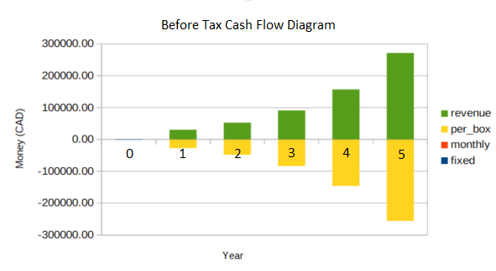

Figure 4 – Before Tax Cash Flow Diagram

## Taxes

Since we have depreciable assets in the form of tools we’ve purchased, we can use the CCA to depreciate it and provide us with tax shield. As they are tools each costing less than $500, they are depreciated as class 12 assets[27], which means that they can be depreciated 100% in a single year. We can deduct this from first year of tax.

In a sole proprietorship, taxes are done just like a regular income[28]. Given the complicated nature of marginal tax rates, and the abundance of online calculators, I’ve used an online calculator[29] to calculate taxes per each year. To account for other sources of income, I’ve added $60000 (my estimated employment earnings) to the cash flow when inputting to tax calculator, and subtracted the resulting tax by tax on $60000 alone (which is $14994). Note that first year’s tax are less because of tools’ CCA. They are presented below:



Table 3 – Net Profit After Tax

## Opportunity Cost and Rate of Return

To make a rate of return analysis useful, we need to set a benchmark to compare the calculated rate to. This benchmark is the minimum attractive rate of return, which is the opportunity cost of investing in this business rather than putting money somewhere that guarantees this return. As a common person looking to invest money long term, the easiest avenue is through stocks, whether it is index funds or ETFs. A reasonable index we can look at is S&P 500, which on 20 years, returns 5.90% per year on average[30]. We can use this value as our MARR, since we’re forgoing this return to invest in our business; the business has to make at least this much to be worth it. We can assume that inflation is already accounted for in this MARR, since it is based on actual stock returns where inflation is present.

To find the rate of return of this business, we can plot the net present value (after tax) along a set of interest rates and find where net present value is zero. The equation is as follows:

NPV = -830.70 + 1706.36(1+i)-1 + 3693.34(1+i)-2 + 5641.21(1+i)-3 + 8213.92(1+i)-4 + 11257.11(1+i)-5

Plotted, we can see that the rate of return of this investment has a rate of return of approximately 288%, exceeding MARR by a significant amount.

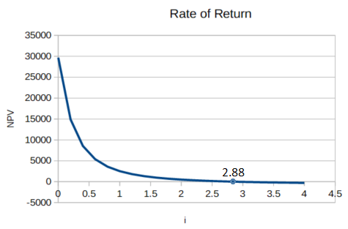

Figure 5 – Rate of Return Plot

## Risk Analysis

While the rate of return presented in the previous section may look incredibly attractive, we have to remember that startups are a risky investment. Recall the previous statistic about businesses failing[6]:

“approximately 20% of new businesses fail during the first two years of being open, 45% during the first five years...”

We can do a simple breakdown to get the chance of a new business failing per year. In the first two years, there’s a 20% chance, so on average there’s a 10% chance of failure in year 1 and year 2. In the first five years, there’s a 45% chance, so subtract that by 20% and divide it by three, and we can see that there’s an 8.33% chance of failing in year 3, year 4, and year 5. For simplicity’s sake, we’ll say that the business lost all of a year’s revenue if it fails in that year. For example, in case of year 1 failure, we’ve made no profit in year 1 through 5, but we have incurred year 0 fixed costs. Another simplification is to forgo salvage value of the tools we bought; we can assume that whatever money we make from salvage will be used to cover leftover inventory payment and disposal (for example, leftover packaging boxes). To convert the values to present value, we’ll use our MARR as the interest rate.

These values can be used to calculate variance, overall expected benefit, and the overall standard deviation. The calculated values are useful for assessing risks in an investment. The original values as well as the calculated values are presented below:



Table 4 – Risk Analysis Values and Calculations

The equations for each calculated values are discussed in Appendix.

According to a rule of thumb presenting in lecture 14-2, “if the expected present worth is at least double the standard deviation of the present worth, then the project is relatively safe”. We can see here that the expected present worth isn’t double the standard deviation; therefore, we can conclude that this is a risky investment – as some would say is typical of a startup.

# Note on Non-Economic Concerns

## Ethics

Given that this business is predicted to be operated by myself only, I have full incentive to treat myself with the utmost ethical employment standards. When time comes for business to expand, I will ensure that this business continues to treat all its employees with utmost respect, and I will also ensure that this business vets its investors and does not take investments from unethical sources, a common problem in the startup world[30].

Additionally, this business’ mission aligns directly with EGBC’s code of ethics. Point #10 of the code of ethics states that engineers should “extend public knowledge and appreciation of engineering and geoscience”[31]. By creating easily accessible and fun toys, this business directly teaches kids about engineering and creates a lifelong appreciation for the field.

## Sustainability

This business is committed to social, economic, and environmental sustainability. Socially, this toy promotes STEM learning in children, fostering a smarter and more thoughtful future citizens. Economically, this subscription set is made in Canada unlike other STEM toy subscriptions; its purchase promotes the development of a healthy local economy. It is also priced competitively so people can afford to buy this toy, reducing the knowledge gap between wealth classes.

While the social and economic benefits are clear, environmental sustainability needs addressing, with two of the points being shipping and wastes. Recently, fast shipping associated with online purchases has come under scrutiny for its environmental impact[32]. However, this company uses the slowest shipping option provided by Canada Post, which allows more package consolidation and reduces the shipment’s carbon footprint (not to mention the benefit of lowered cost). Additionally, Canada Post is highly committed to sustainability[33], further reducing impact.

In terms of waste, the packaging and the booklet are paper so they are recyclable. The toys themselves are trash when tossed, but the idea is that they are kept with the children because of they can be replayed or handed down, so the waste impact seen from them are hopefully minimal. The bigger conversation to be had around this, however, is the efficiency of recycling programs in Canada, which has been impacted by China’s changing policy in 2018[34]. This business commits to supporting lobbies that improves sustainable measures regarding business operations.

# Conclusion

This unnamed startup venture provides Canadian kids with a subscription to STEM-teaching toys, competitively priced and highly educational. Data on costs and revenues, compiled based on online vendors, personal experiences, and similar companies, were used for analyses (cash flow before and after tax, rate of return, and risk) that showed that even though the rate of return is very attractive, we should make further, thoughtful considerations before investing in this project due to its equally apparent risks. Quantitatively, the expected benefit in a five-year time span is $15442.82, with standard deviation of $10043.66. On non-economic concerns, this business recognizes ethical and sustainability concerns and commits to improvements on those issues.

# Bibliography

All links are most recently accessed on August 19th, 2020.

[1] <https://bench.co/blog/small-business-stories/subscription-box-business/>

[2] https://www.mysubscriptionaddiction.com/best-subscription-boxes/best-beauty-boxes

[3] <https://all3dp.com/2/history-of-3d-printing-when-was-3d-printing-invented/>

[4] [https://www.kiwico.com](https://www.kiwico.com/)

[5] [https://www.greenkidcrafts.com](https://www.greenkidcrafts.com/)

[6] <https://www.investopedia.com/financial-edge/1010/top-6-reasons-new-businesses-fail.aspx>

[7] https://www.amazon.ca/Comgrow-Creality-Printer-Tempered-220x220x250mm/dp/B07V4RTYQF

[8] https://www.aliexpress.com/item/4001209363899.html

[9] [https://www.amazon.ca/AMZ3D-1-75mm-Printer-Filament-Black/dp/B01BZ5ND8O](https://www.amazon.ca/AMZ3D-1-75mm-Printer-Filament-Black/dp/B01BZ5ND8O/ref=sr_1_5?crid=3HPIB5DU4QCZI&dchild=1&keywords=3d+printer+filament&qid=1597869205&sprefix=3d+printer+%2Caps%2C213&sr=8-5)

[10] <https://www.homedepot.ca/product/alexandria-moulding-standard-hardboard-panel-1-8-inches-x-24-inches-x-48-inches/1000132234>

[11] [https://www.greenkidcrafts.com](https://www.greenkidcrafts.com/)

[12] <https://www.kiwico.com/tinker1>

[13] <https://www.jukeboxprint.com/booklet-printing-in-vancouver>

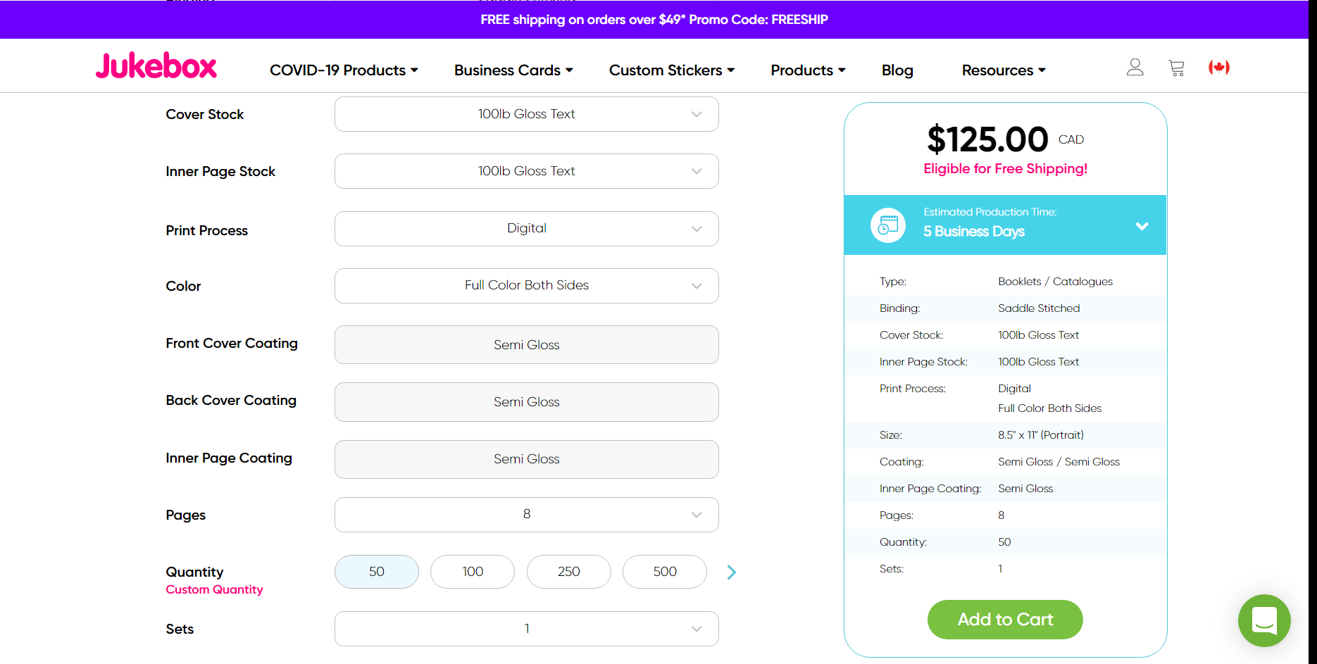

[14] <https://www.uprinting.com/mailer-boxes.html>

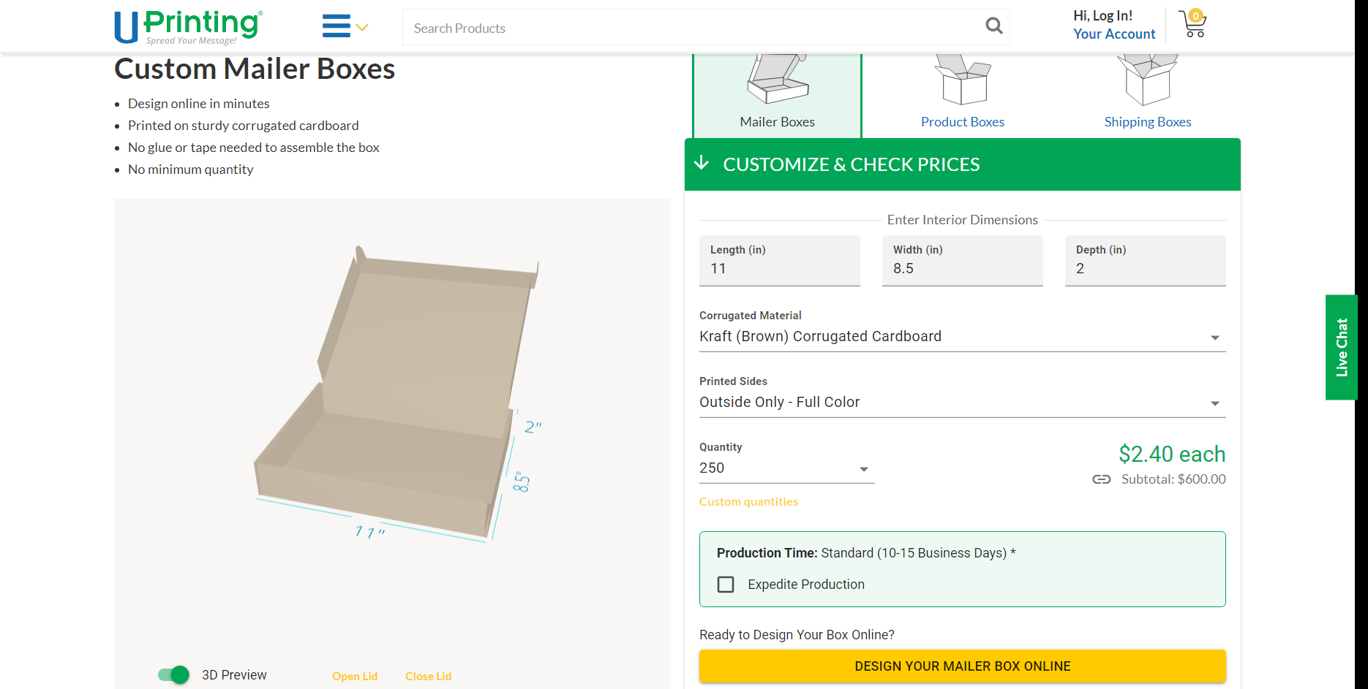

[15] <https://www.canadapost.ca/cpotools/apps/far/business/findARate?execution=e1s5>

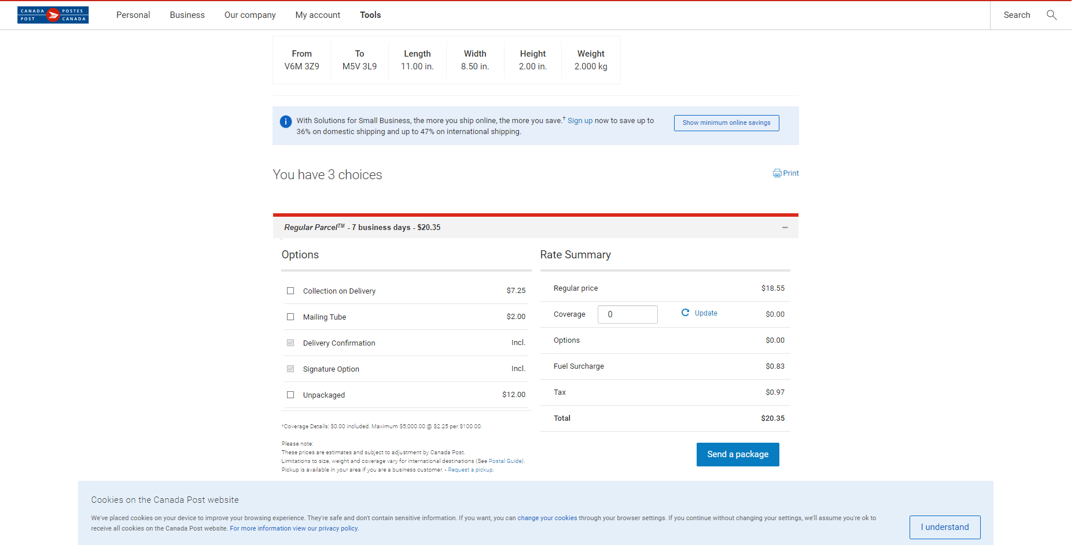[16] <https://www.shopify.ca/pricing>

[17] https://www.bankofcanada.ca/rates/related/inflation-calculator/

[18] https://www.taxtips.ca/salestaxes/sales-tax-rates-2020.htm

[19] <https://incfact.com/company/kiwico-losaltos-ca/>

[20] https://www.owler.com/company/kiwicrate

[21] https://www.forbes.com/sites/michellemartin/2018/08/31/how-this-100m-subscription-box-company-is-inspiring-little-global-citizens

[22] <https://www.fastcompany.com/90248232/inside-the-2-6-billion-subscription-box-wars>

[23] <https://pitchbook.com/profiles/company/52965-01>

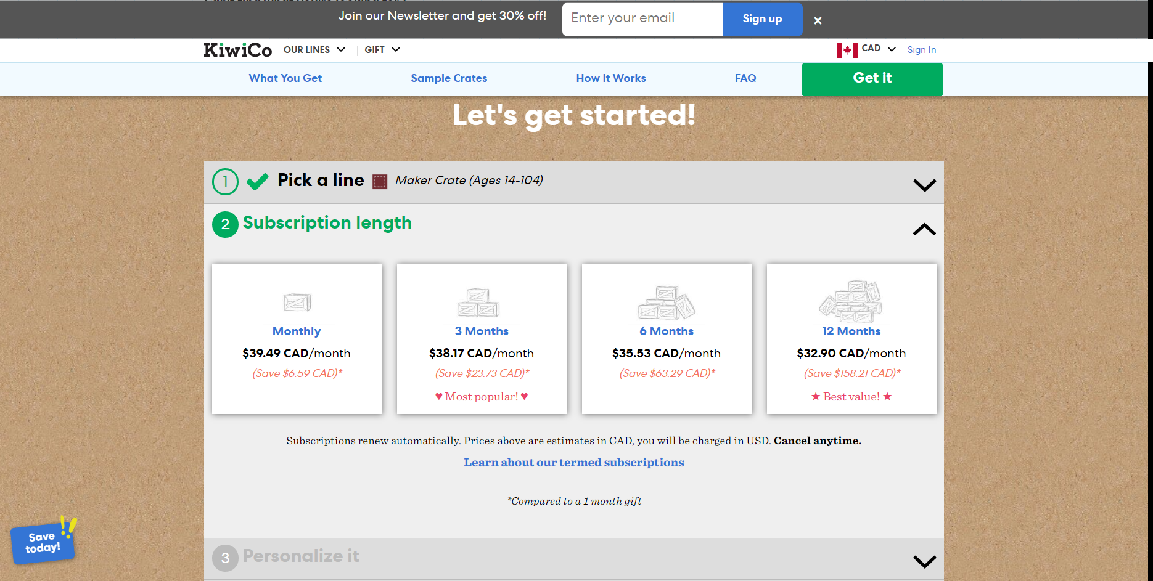[24] <https://kiwico.com/maker>

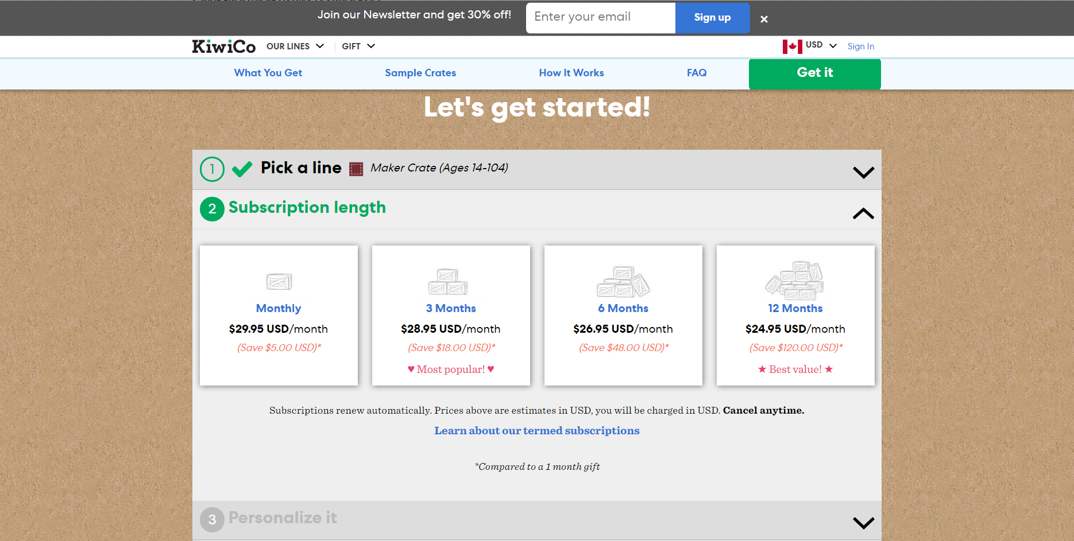

[25] <https://www.worldometers.info/world-population/population-by-country/>

[26] [https://kiwico.com](https://kiwico.com/)

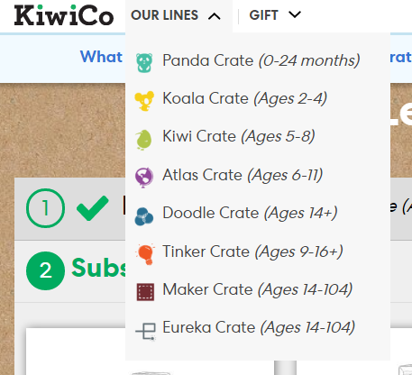

[27] [https://www.canada.ca/en/revenue-agency/services/tax/businesses/topics/sole-proprietorships-partnerships/report-business-income-expenses/claiming-capital-cost-allowance/classes-depreciable-property.html#class12](https://www.canada.ca/en/revenue-agency/services/tax/businesses/topics/sole-proprietorships-partnerships/report-business-income-expenses/claiming-capital-cost-allowance/classes-depreciable-property.html" \l "class12)

[28] <https://turbotax.intuit.ca/tips/income-tax-rates-for-the-self-employed-6393>

[29] <https://simpletax.ca/calculator>

[30] [https://www.wealthsimple.com/en-ca/learn/average-stock-market-return#what\_does\_this\_mean\_for\_us\_as\_investors](https://www.wealthsimple.com/en-ca/learn/average-stock-market-return" \l "what_does_this_mean_for_us_as_investors)

[30] <https://www.theguardian.com/world/1mdb>

[31] [https://www.egbc.ca/Complaints-Discipline/Ethics,-Law,-and-Conduct#APEGBCCodeofEthics](https://www.egbc.ca/Complaints-Discipline/Ethics,-Law,-and-Conduct" \l "APEGBCCodeofEthics)

[32] <https://www.cnn.com/2019/07/15/business/fast-shipping-environmental-impact/index.html>

[33] <https://www.canadapost.ca/cpc/en/our-company/about-us/corporate-sustainability.page>

[34] <https://globalnews.ca/news/5199883/canada-recycling-programs/>

# Appendix

If not here, the relevant calculations are covered in-text.

## Risk Calculations

Variance = (Benefit of n)2 \* Probability of n happening

Expected benefit = Sum(Benefit of n \* Probability of n happening)

Standard Deviation = Sqrt(Sum(Variance) – (Expected benefit)2)